**Question 1:**

Which of the following is used to show the best fit line when exploring the correlation between two measures?

1. Reference lines
2. **Trend Lines**
3. Histograms
4. Drop lines

**Question 2:**

Which of the following best describes the forecast model selection in Tableau?

1. **Automatic, with configurable forecast options.**
2. Automatic, with no configurable forecast options.
3. Not Automatic, all forecast options need to be configured

**Question 3:**

Create a view of sales by region and segments. And compares sales in each customer segment to the average. Find out which regions are below average in every segment?

1. East and West
2. **Central and South**
3. South and West
4. Central and East

**Solution-**

Drop segment and region to Columns and Rows respectively. Drop Sales to the Columns as well.

Now go to Analytics and Select Reference Line. Drop it to chart and Select Scope as Per Pane. Aggregation must be Average.

Your view will look like this:

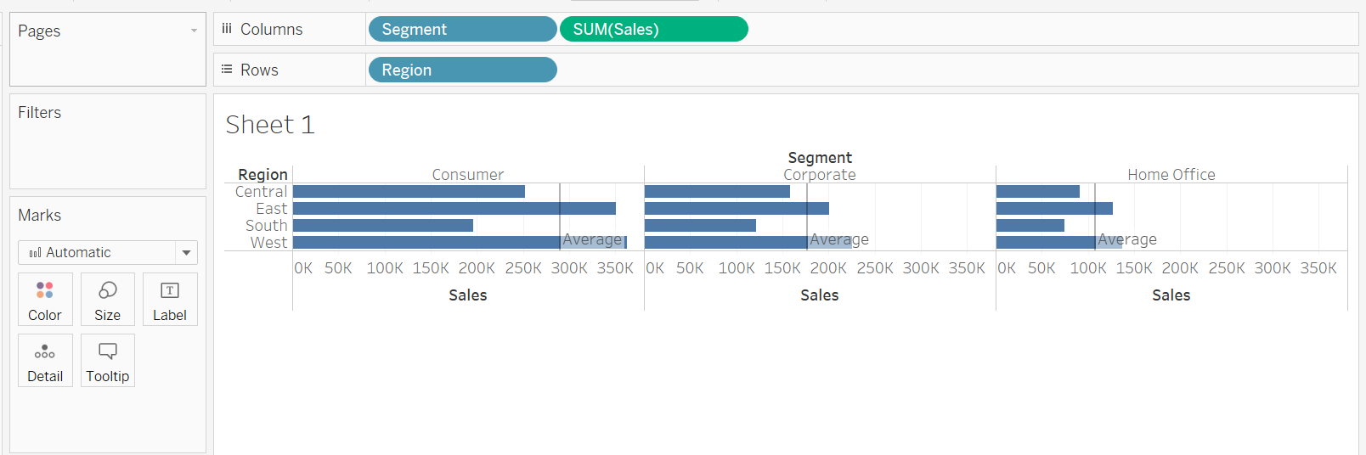

**Central and South** Regions are below average in every segment.